

KGiSL INSTITUTE OF TECHNOLOGY

**Project_Title : Website Traffic Analysis**

**Mentor :** Indu Poornima R

**Team Members :**

NAVEEN SG

RAVINDRANATH M

LOKESH KV

BALAGANESH M

**Project Description :** Social analysis of web traffic aWeb traffic analysis refers to the process of examining and interpreting the behavior of visitors on a website. It involves collecting, analyzing, and interpreting data related to the number of visitors, their interactions, and the content they consume. This practice is crucial for businesses, marketers, and website owners as it provides valuable insights into the effectiveness and performance of a website.

**Objective :**

The objective of web traffic analysis is to gather, analyze, and interpret data related to website visitors and their interactions with the site.

**#Step_1 :**

Mounting the colab with the google drive for attaching the dataset to the program.



**#Step_2 :**

Loading the raw dataset from the drive by mounting it to the colab.



**#Output :**

**­­­**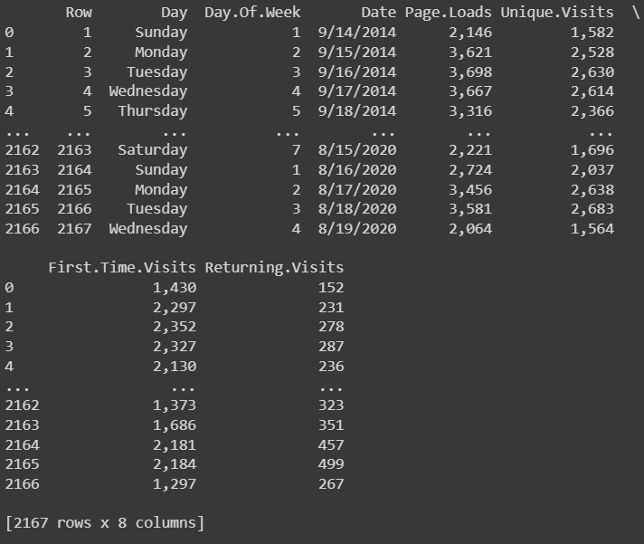

**#Step_3 :**

The step involves the processing and cleansing of the raw dataset.

**#Processing :**

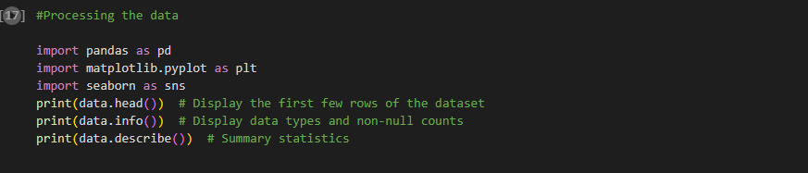

**#Output :**

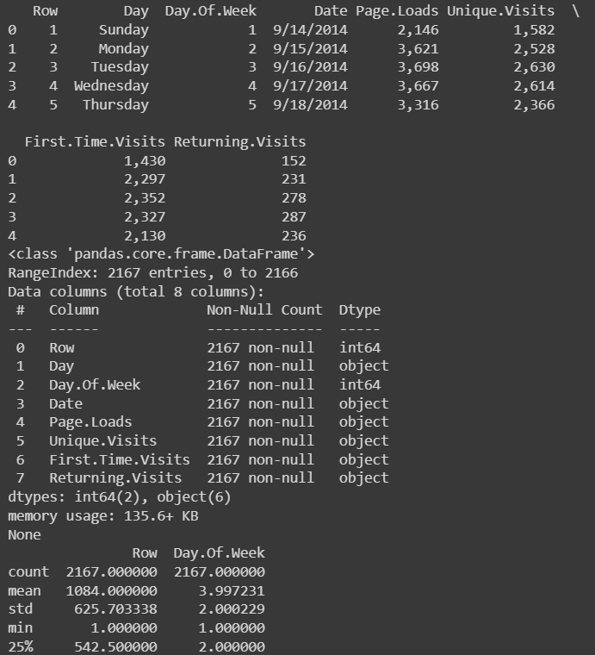

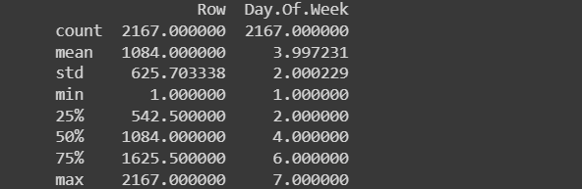

**#Cleansing :**

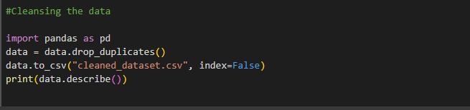

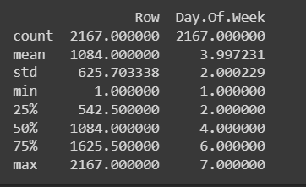

**#Step_4 :**

This step involves the accuracy of the whole dataset.

